PROJECT REPORT

TITLE: WALLYGRAM

COHORT: JUNIHERS

GROUP MEMBERS:

Anushka Srivastava

Shruti Sharma

Gyanvi

Diya Pancholi

Siddam Shetty Sahithi Shresta

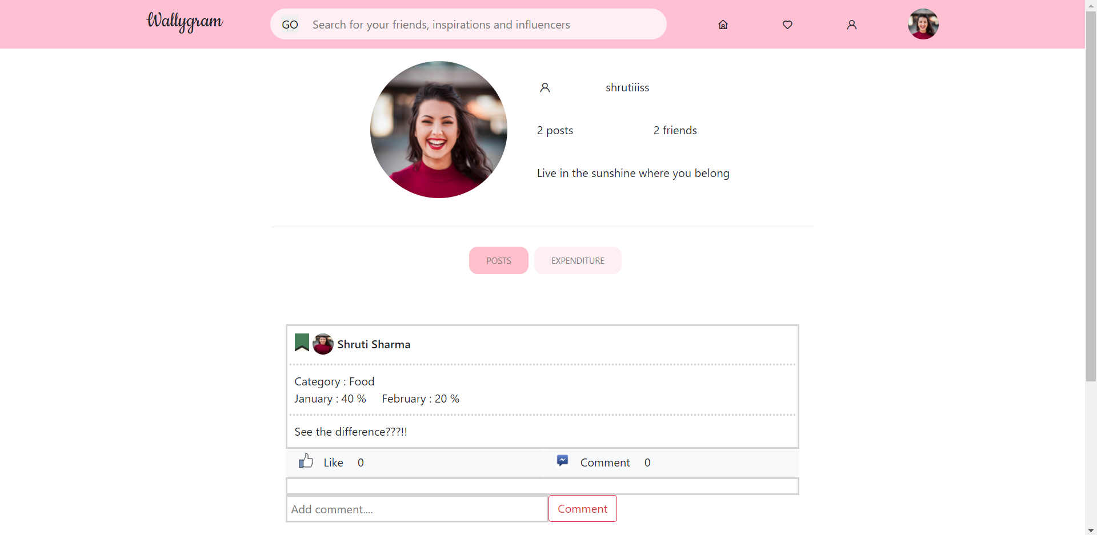

Table of Contents

| Sr. No. | Title | Page No. |
| --- | --- | --- |
| 1 | Cover | 1 |
| 2 | Table of Contents | 2 |
| 3 | Executive Summary | 3 |
| 4 | Project requirements | 4 |
| 5 | Design and Architecture | 5 |
| 6 | UI/UX snippets | 8 |
| 7 | Future Scope | 12 |
| 8 | References | 13 |

Executive Summary

The project is for a web application called ‘Wallygram’, which serves as an expenditure analysis and expense sharing platform among friends, combining social media with wallet analysis. It provides detailed information about the different patterns in our monthly spending and draws comparisons for the same. To access the platform, a user has to log in/sign up and they will land on their profile page. The profile will include a full breakdown of the user's monthly finances, broken down into sections. Visualizations displayed are of two types:

* Comparison - Compares the user's expense in a particular category between 2 months.
* Category - This allows the user to choose a category and its sub payments, and give their reviews about the purchase.

They can choose to share this data in the form of posts, with their friends.

They can send and accept friend requests, and their feed will show the latest expenditure posts of all their friends.

Often we end up making e-transactions from our accounts as if they were Mr Gates’. Our goal is to help the user keep a track of their spending habits and to inspire and take inspiration from their peers and make changes as required. Also, the feature of categorically displaying the percentage expenses in pie charts creates a platform that not only assists users in managing and analyzing their daily expenditures but also allows them to exchange and receive vital information in order to spend more efficiently. This website will establish a new class of influencers who will share their good buys, savings, and recommendations with the rest of the globe.

We have used Node.js, implemented our backend using express.js, ejs as our view engine, bootstrap for CSS and have used MySQL for our database. Users will be able to connect to their wallets for fetching the expenses. However, currently, we have not focussed on integration.

Project Requirements

* Each user has their own account and hence, Wallygram requires user authentication.
* Chart and table-based visualizations for input budget segregated into categories.
* Listing of total expenses in a particular category.
* The feature to share a post to display it on your own feed.
* The ability to compare each month’s spending with the previous months, to analyze and keep a check on overspending.
* Option to send, receive, accept and decline friend requests.
* Ability to create and share posts regarding your expenditures with your friends.
* The feature to like any post in your feed to show support and appreciation.
* The feature to comment on any post to share your views.
* To have a profile page, where user details and other information is displayed.

Design and Architecture

1. System Architecture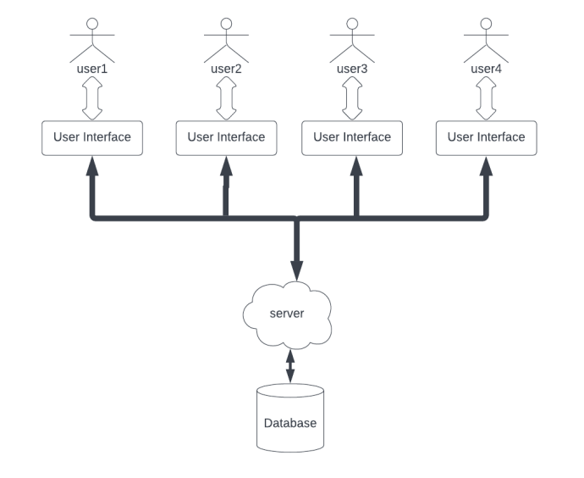

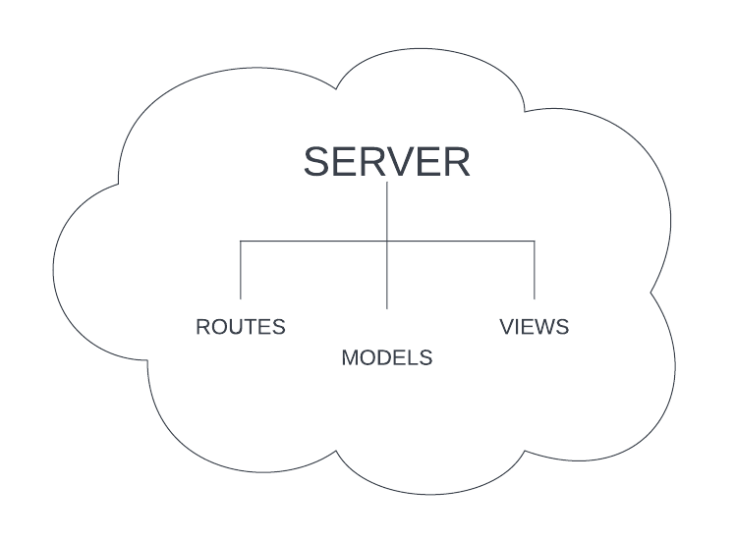

* We have the user interface displayed on our front end. The user interacts with the frontend and corresponding HTTP requests are sent to the server. The queries are run on the database where the results are then sent to the frontend.
* We have stored the SQL queries in models, which take up the responsibility of interacting with the database.

1. The server acts as the brain of the whole system. It listens to the requests from the user, then makes appropriate queries to the database and sends the response to the users.
2. Views: These are responsible for the graphical side of the application. The server renders these views to the user by providing the fetched data from the user. Their logic is separated from other parts. So anything related to the views can be modified, and debugged by reviewing the views only.
3. Database: Database models are used to model the different data involved in the application. A detailed description of the modeling is given in the upcoming section related to database modeling

2. Database Modeling (ER Diagram)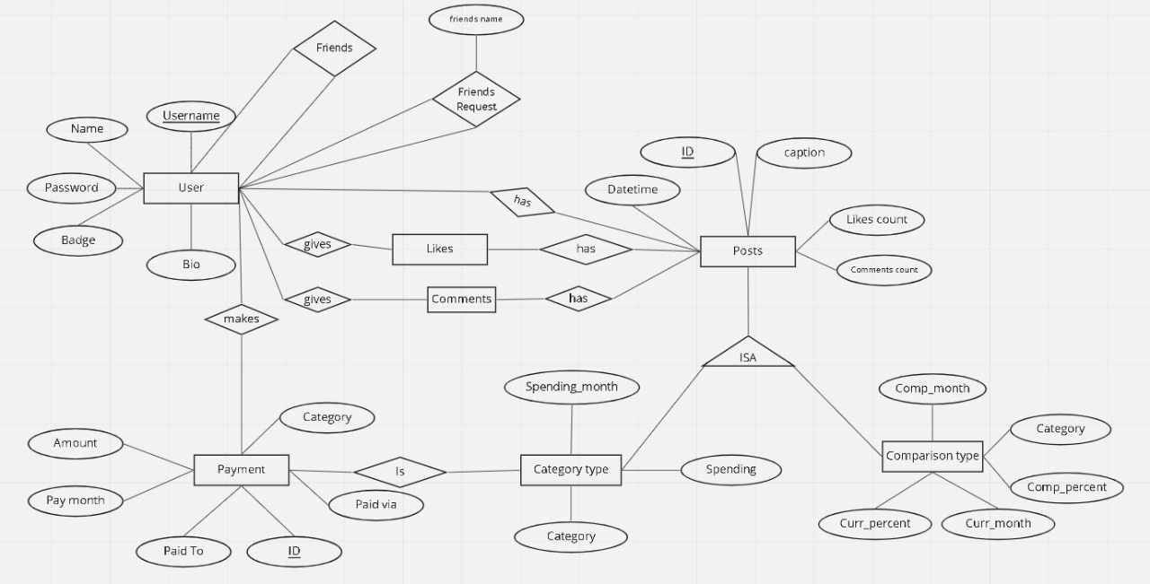

Class diagram:

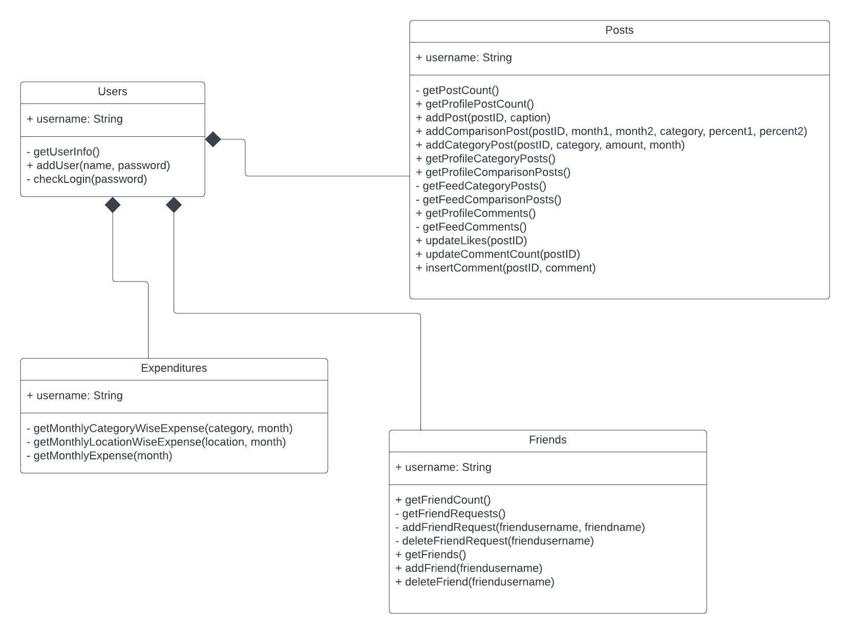

We have primarily 4 classes/models.

1. Users
2. Posts
3. Friends
4. Expenditures

Each one of them has its own member variables and methods.

UI/UX Snippets

First Page

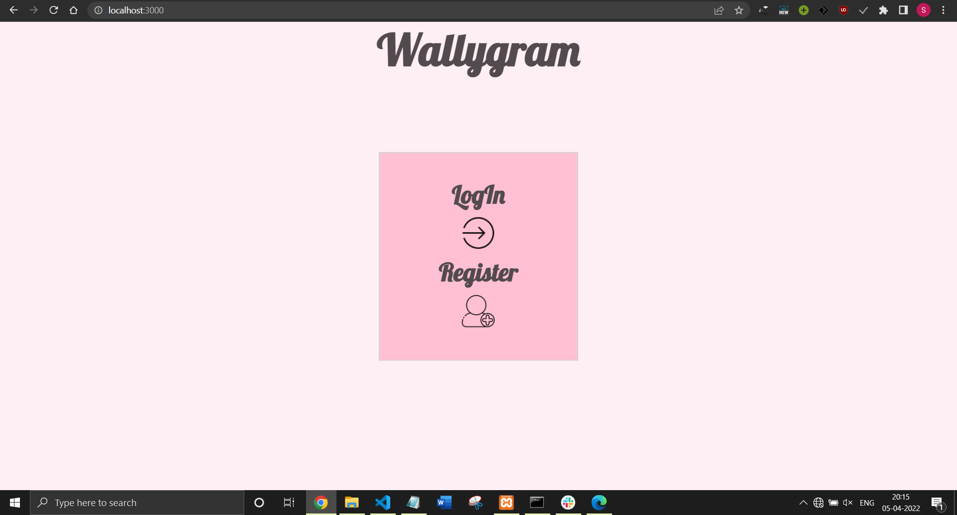

Sign Up Page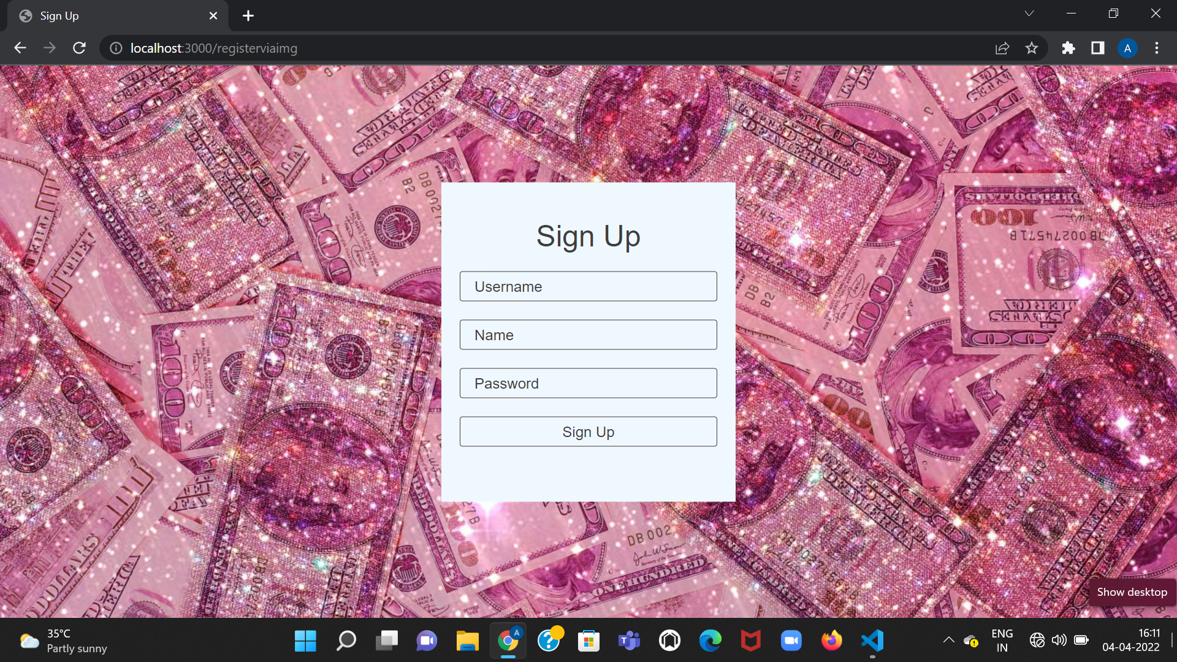

Login Page

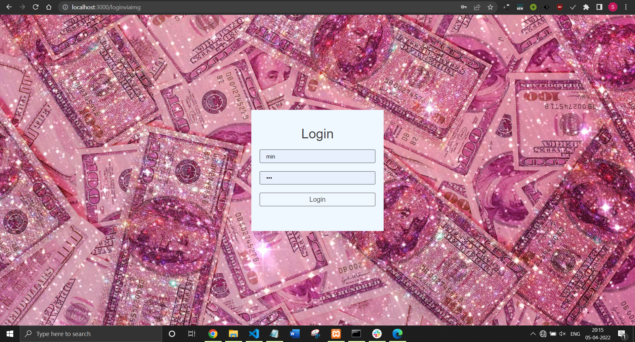

Profile Page

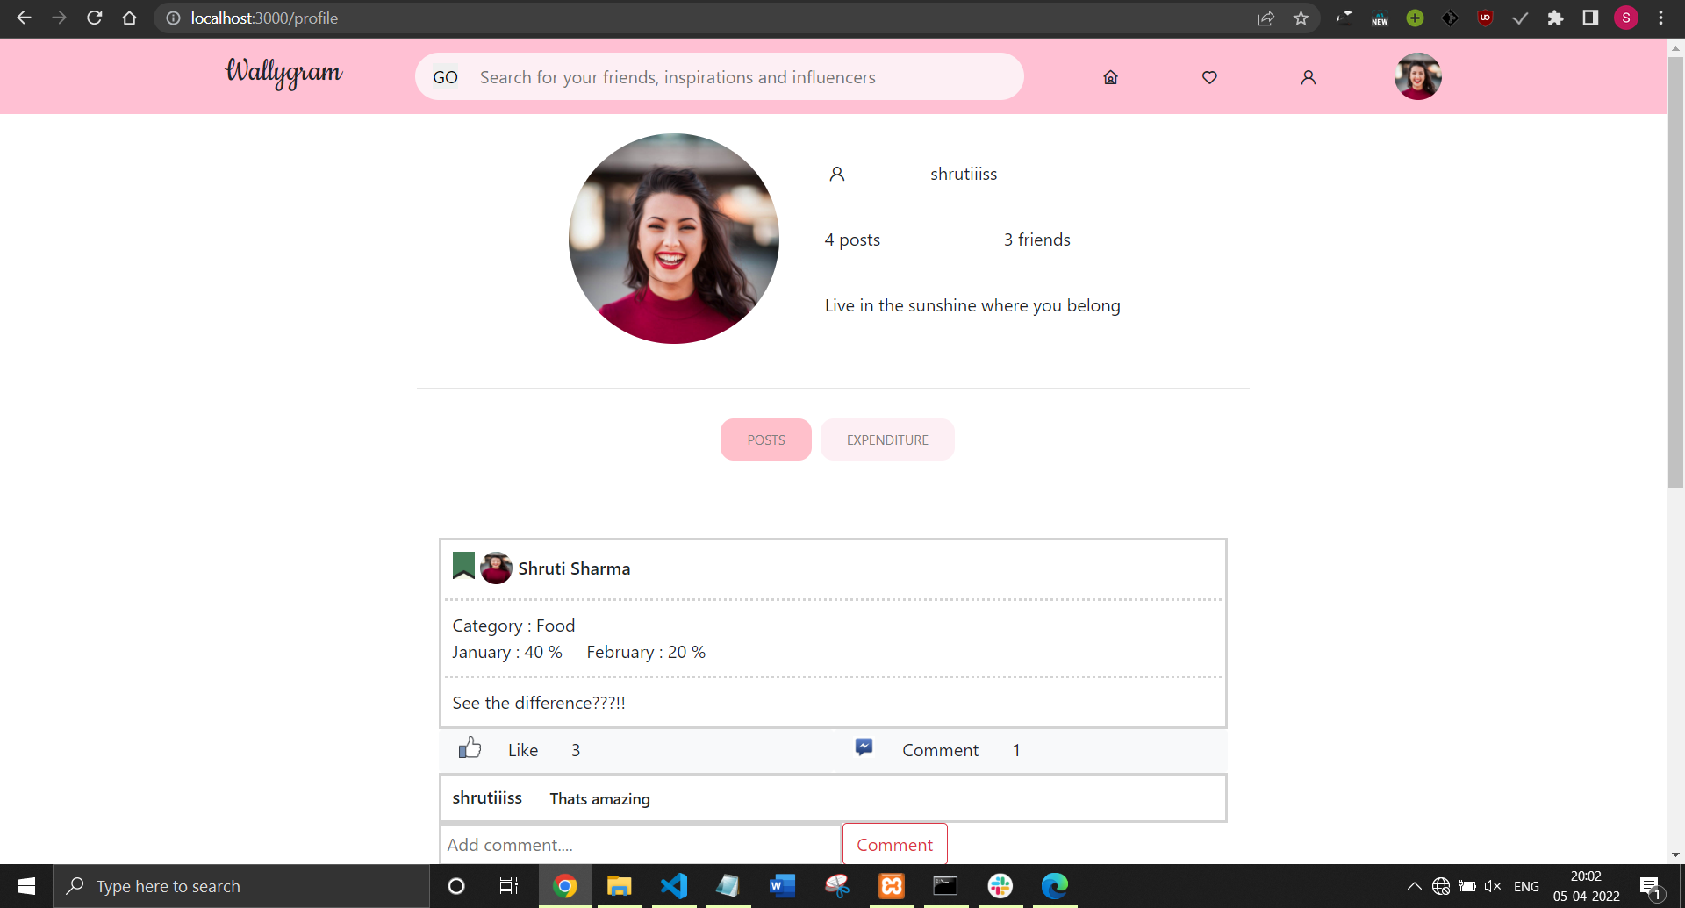

Expenditure Page

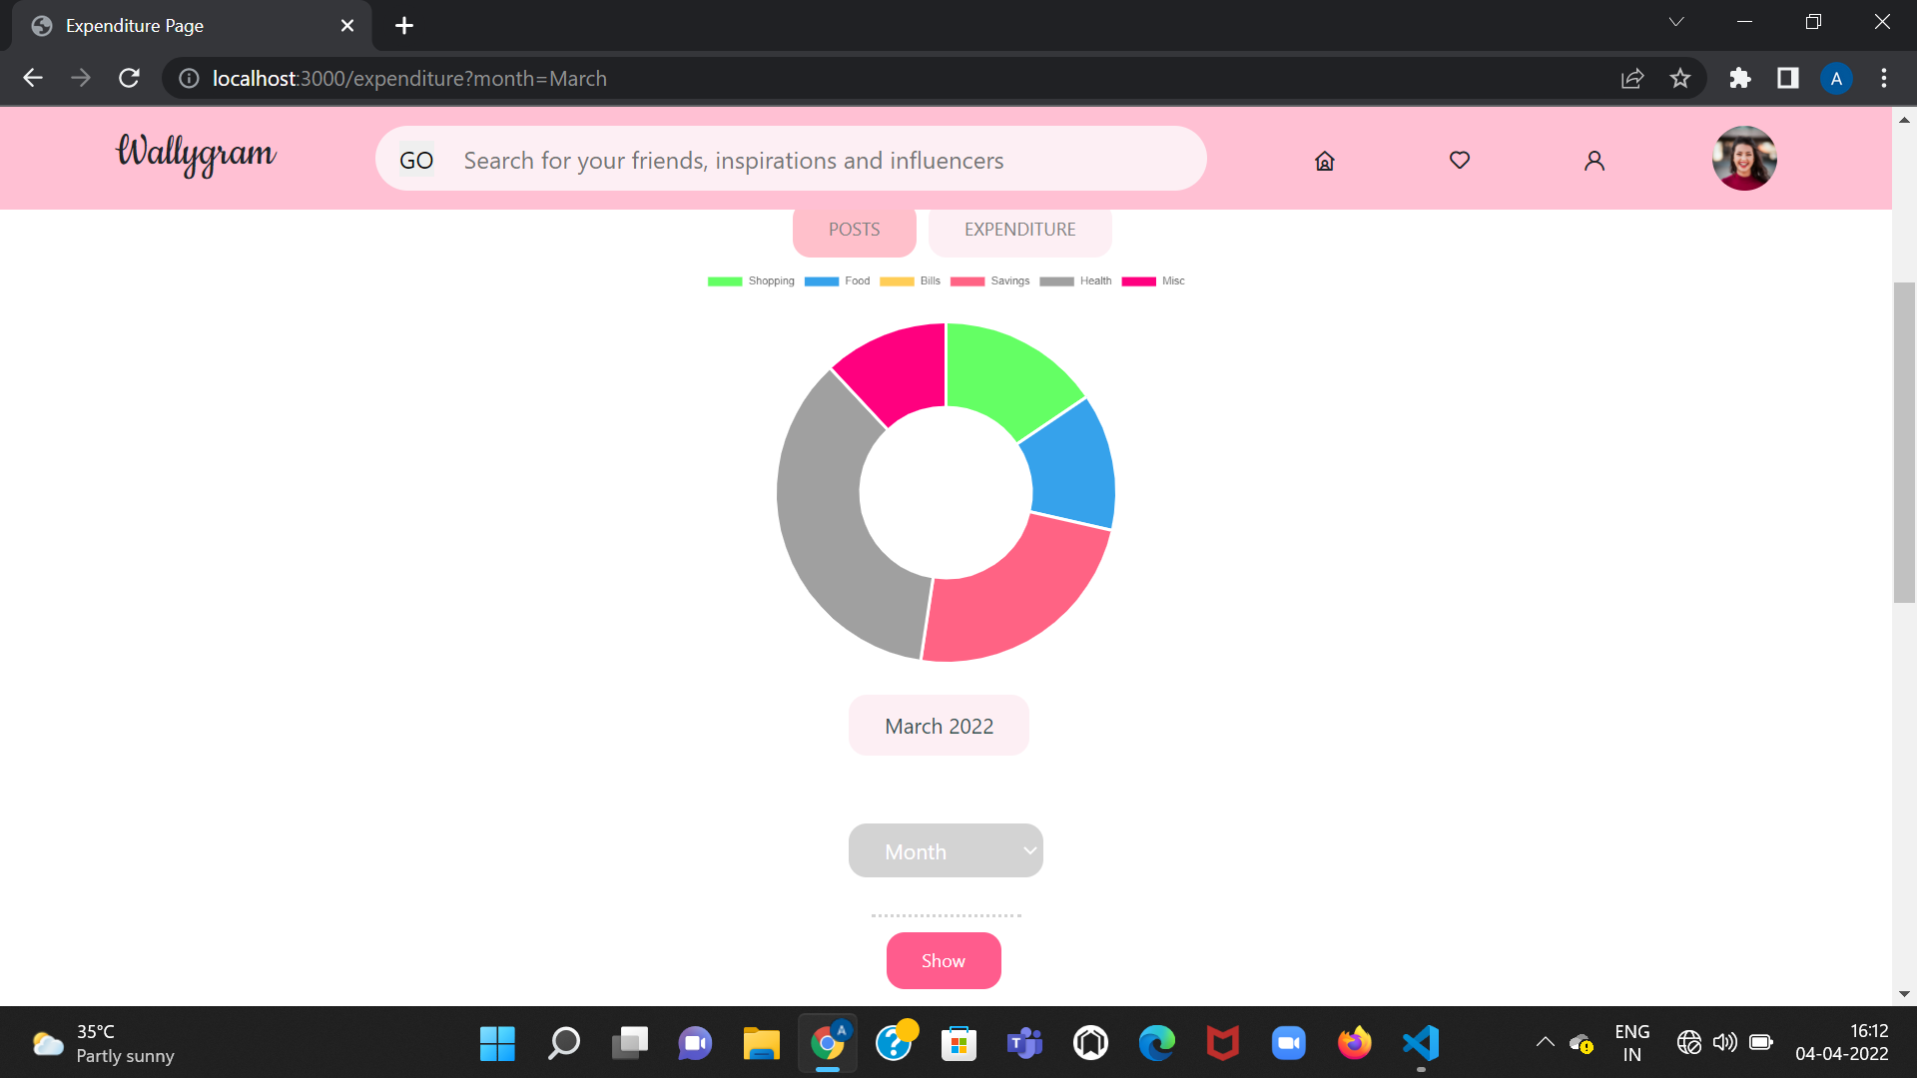

Comparison and Category Type Posts

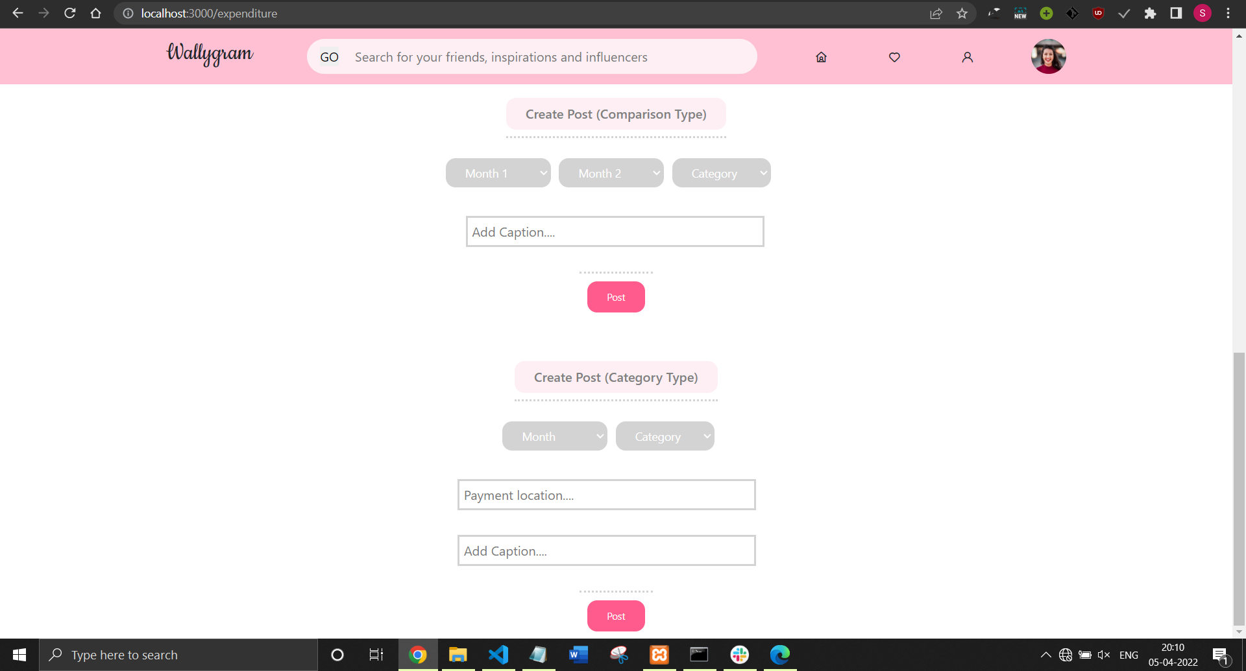

Feed Page

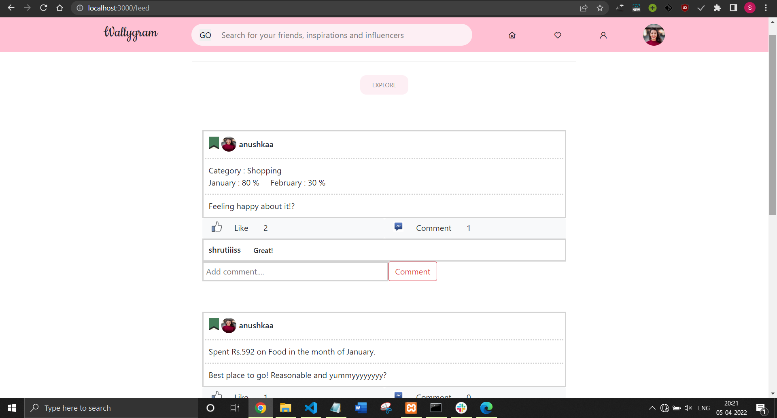

Friends Request Page

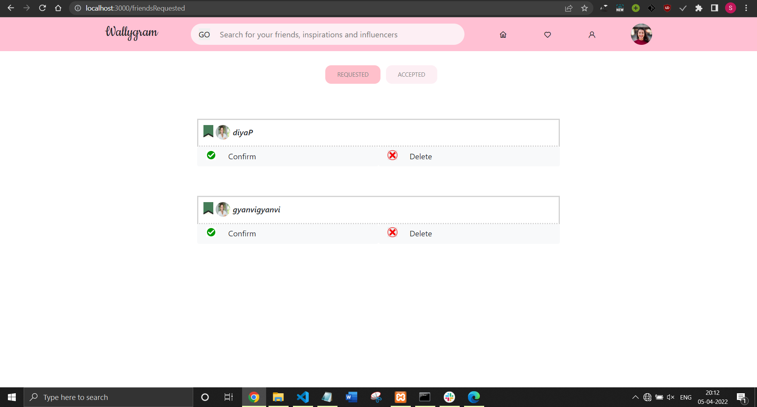

Friends Accept Page

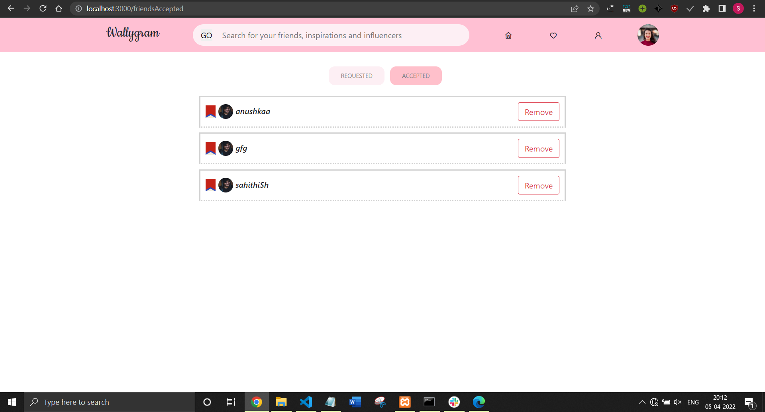

Future Scope

* The users would also be able to share their recommended places and products with their friends, on which they could express their opinions.
* Along with this, the user would be given badges according to savings/expenditure.
* Startup tour/ guide for new Wallygram users to help them easily navigate through our website.
* Due to the short timeframe of 6 weeks, we were unable to integrate wallets, but that is something we are planning on doing next. This would directly update our databases with our daily transactions. This idea has arisen from a very potent need each one of us felt to figure out where we end up blowing off so much money monthly in college. And despite everyone telling us to maintain an expense diary, let’s face it, we literally do not have the time and patience for that. So a quicker option to make payments and choose a category for them to fall into.
* Users can set a monthly savings goal for themselves. If the user saves much more than the target, he or she will receive badges.
* The feature to share a particular expense, with reviews and the option to add images to the post.
* The categories can be customized by the user.

References

* Node js documentation - <https://nodejs.org/en/docs/>
* Express-generator - <https://expressjs.com/en/starter/generator.html>
* Chart.js documentation - <https://www.chartjs.org/docs/latest/>

**Thank you!**